**HS499**

**Log return graph**

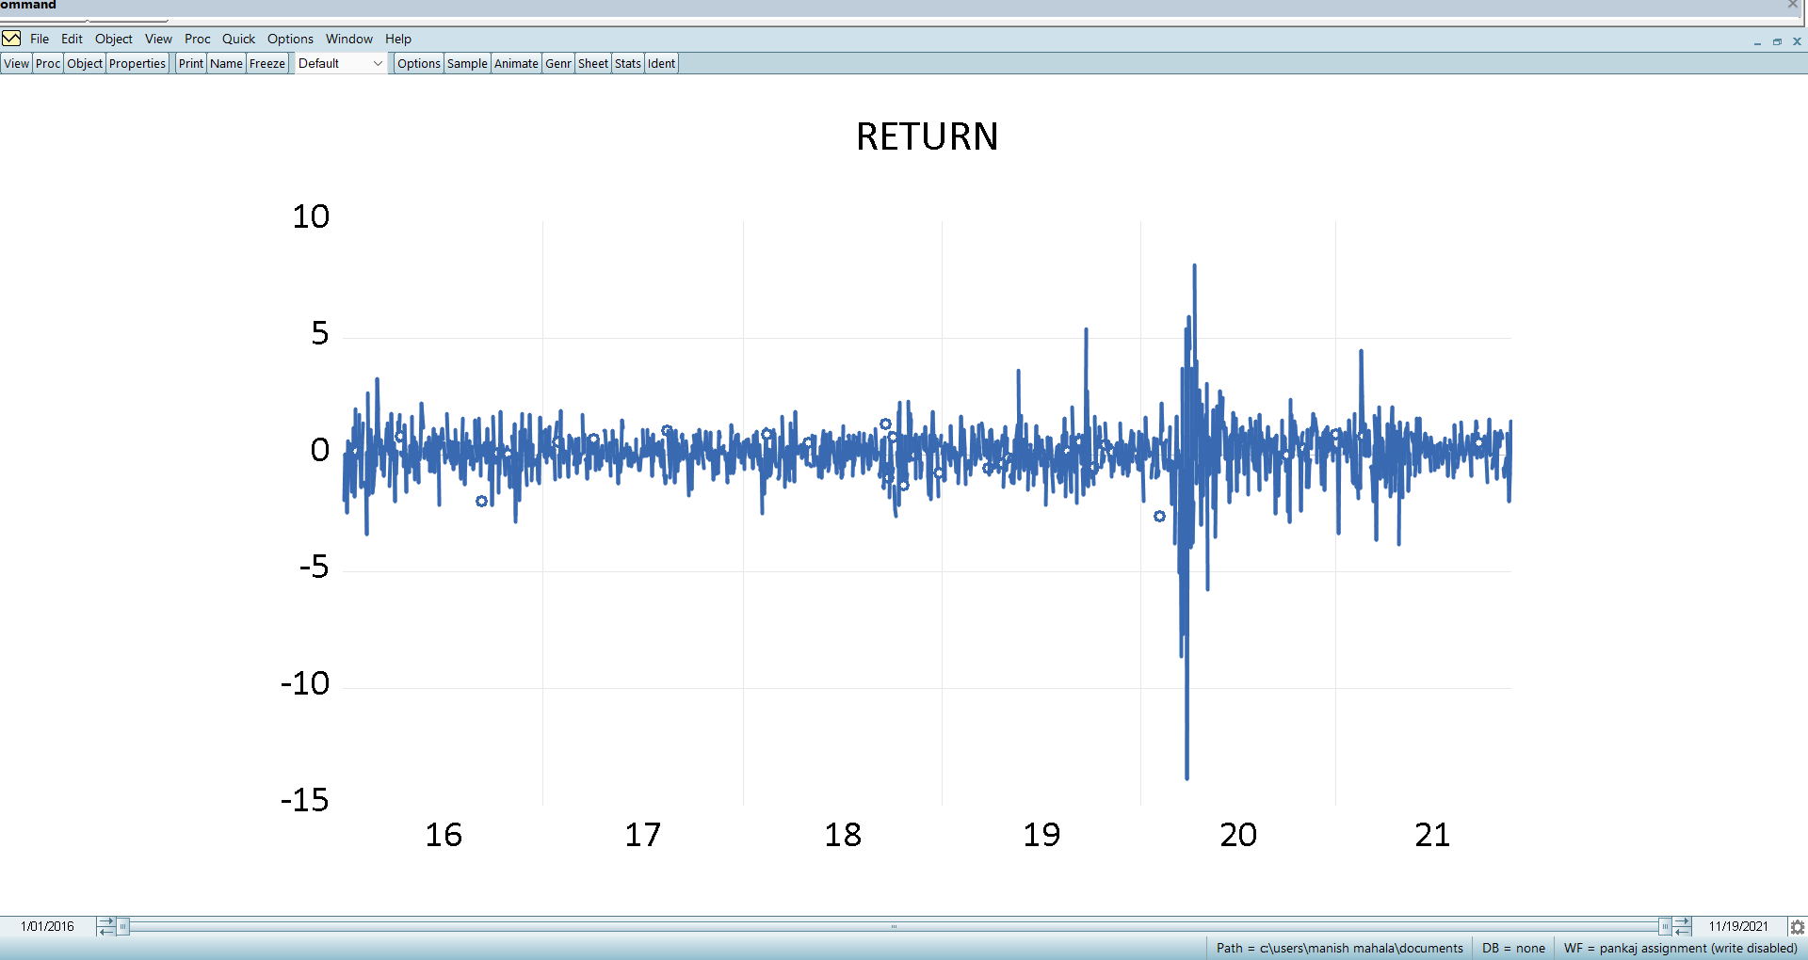

**Descriptive and statistics graph**

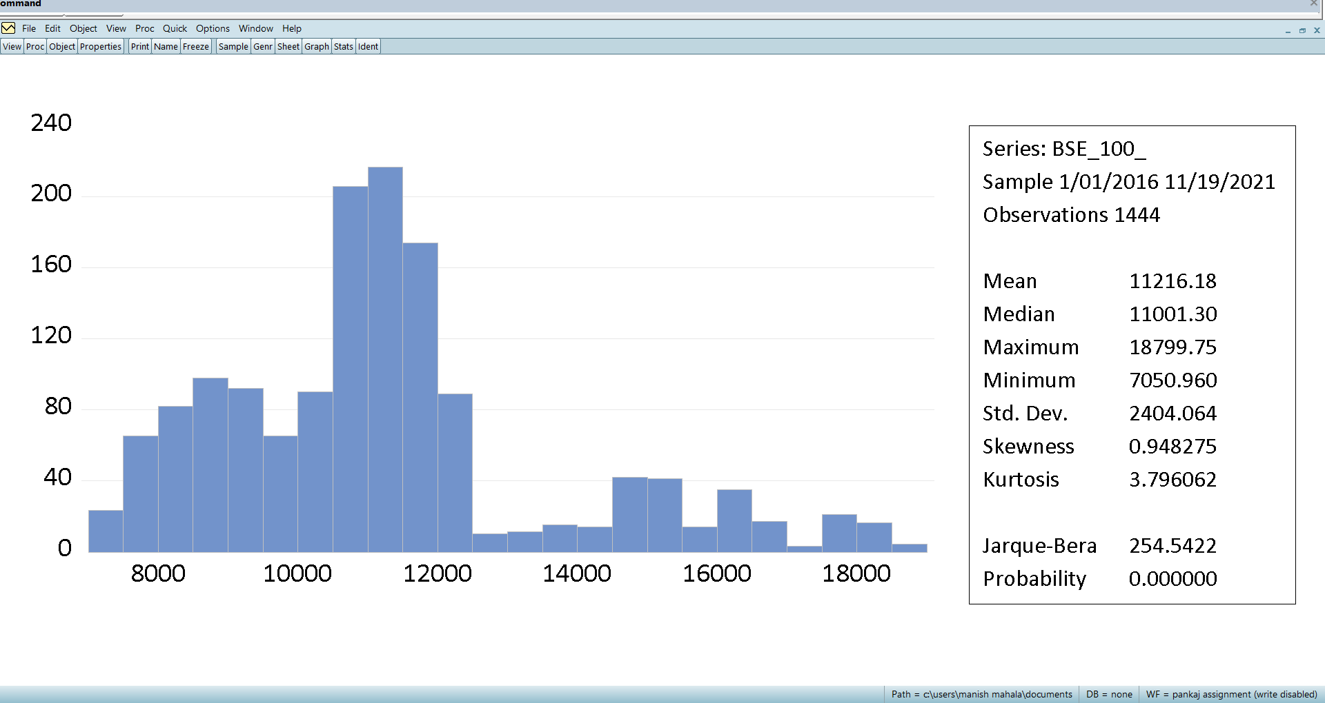

* Mean > Median , and also in the table we got a positive value of skewness and just by a glance at the graph we can say that it is positively skewed, because it has a cluster on the left side and tail on the right side.
* Kurtosis in this case is >3 and thus it is leptokurtic which also can be seen by graph as there is a high peak.
* Range = Max. - Min. = 18799.75 - 7050.96 = 11748.79
* Mean > Standard deviation which means not extremely risky.

**AR model test**

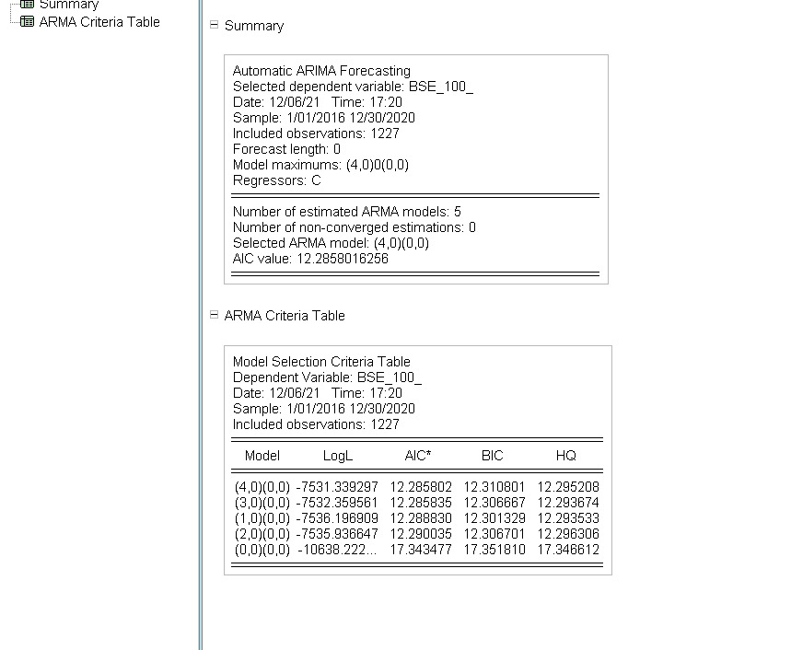

**MA model test**

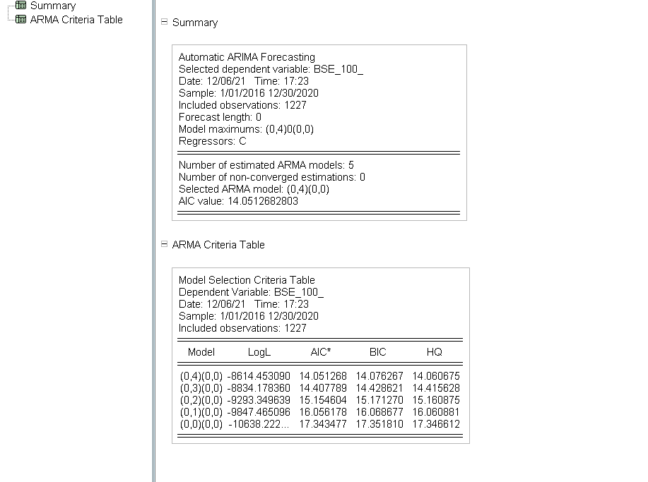

**ARIMA model**

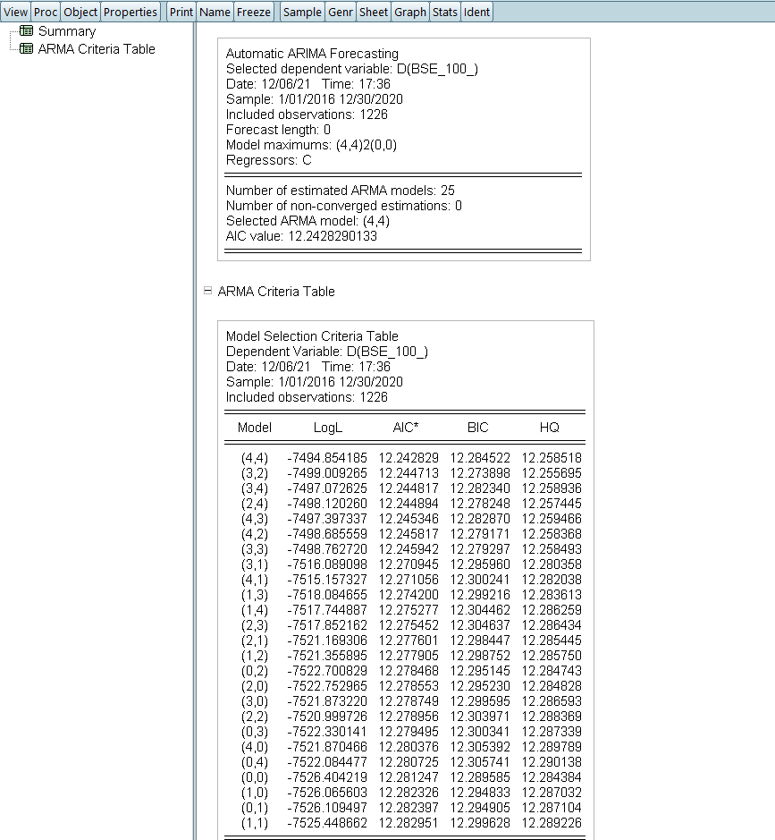

Best models are

* AIC =(4,4) ,(3,2)
* BIC = (3,2) ,((2,4)
* HQ = ((3,2),(2,4)

**Now for model (4,4)**

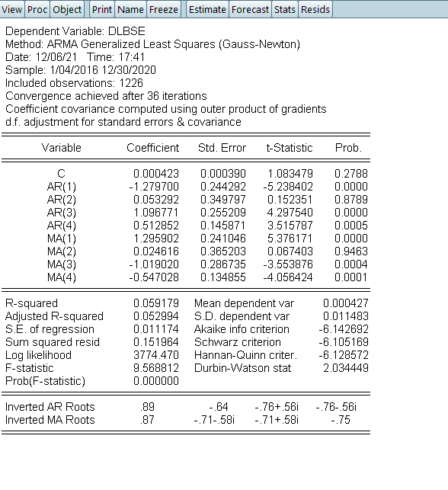

**Residual diagnostics**

**Normal test**

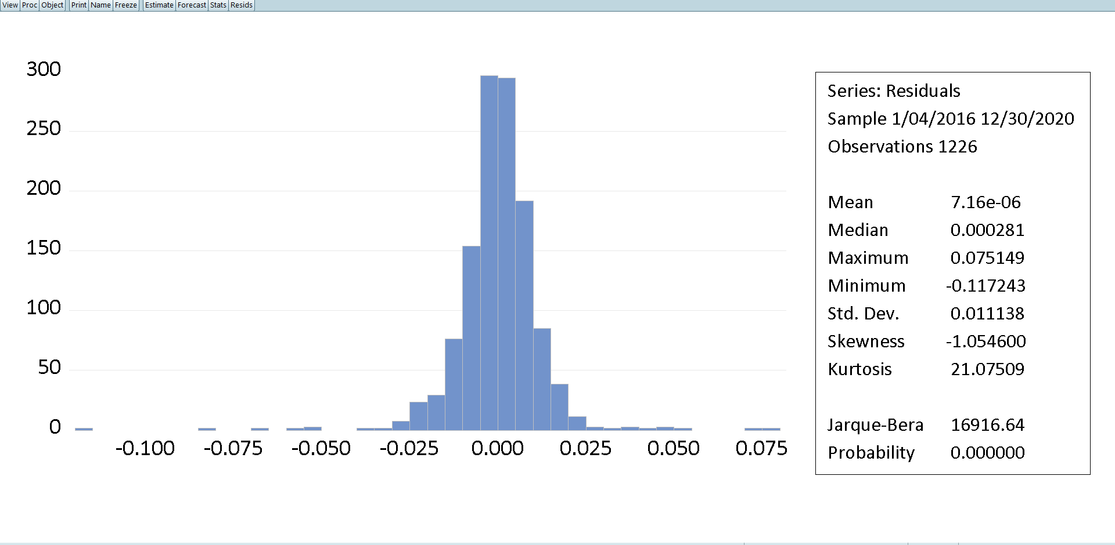

**Correlation test**

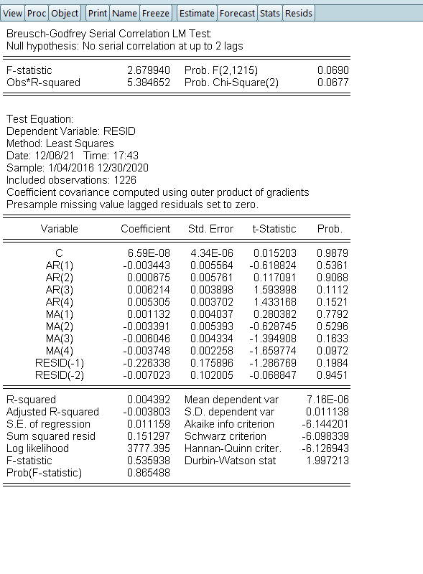

**Heteroscedasticity**

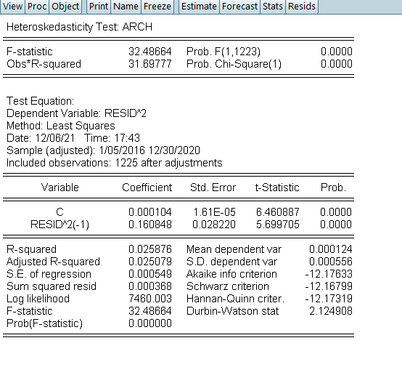

* For model(4,4) R squared is 5.91% and AR(2) and MA(2) are not significant errors are not normal
* In heteroskedasticity p < 5% heteroskedasticity is present
* In autocorrelation P < 10% hence autocorrelation exists

**Model(3,2)**

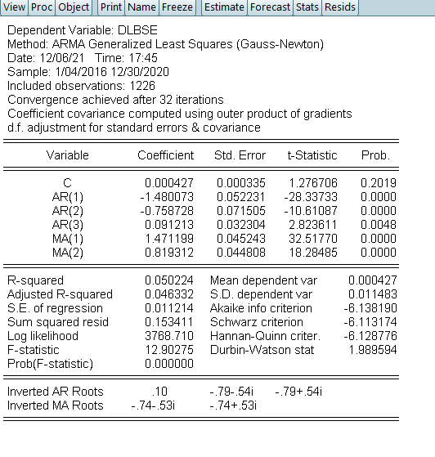

**Residual test**

**Normal test**

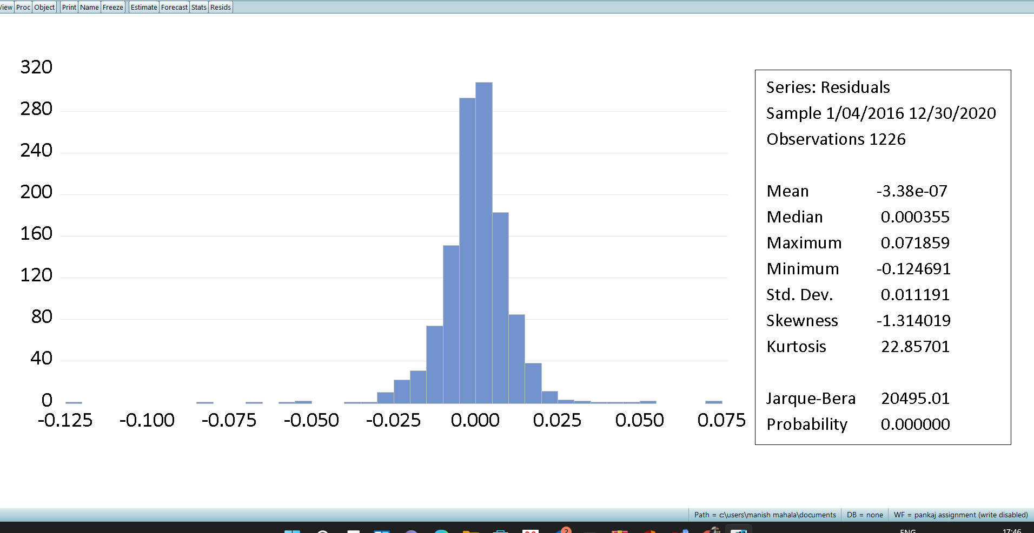

**Correlation test**

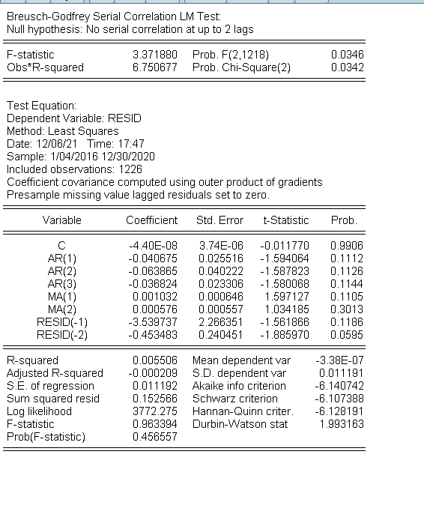

**Heteroskedasticity Test**

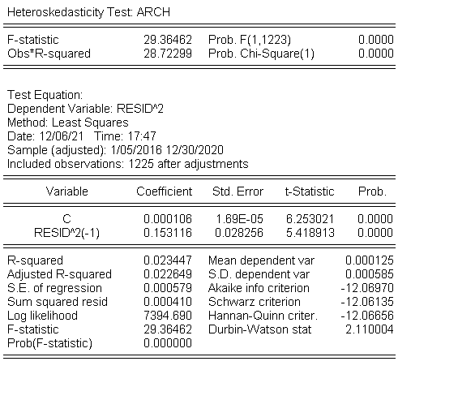

* For model(3,2) R squares is 5.02% and error are not normal
* In heteroskedasticity p < 5% heteroskedasticity is present
* In autocorrelation P < 10% hence autocorrelation exists

**Model (2,4)**

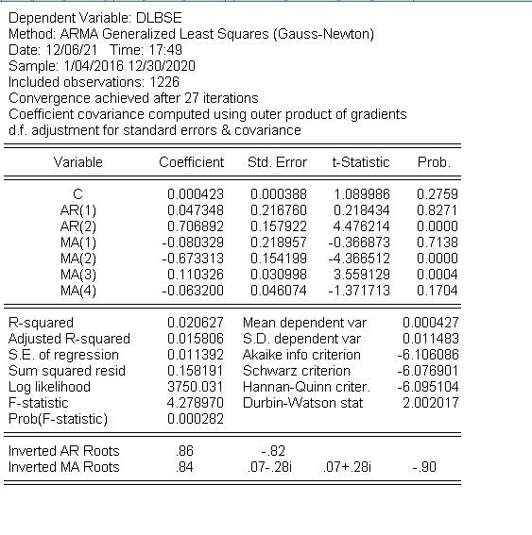

**Residual test**

**Normal test**

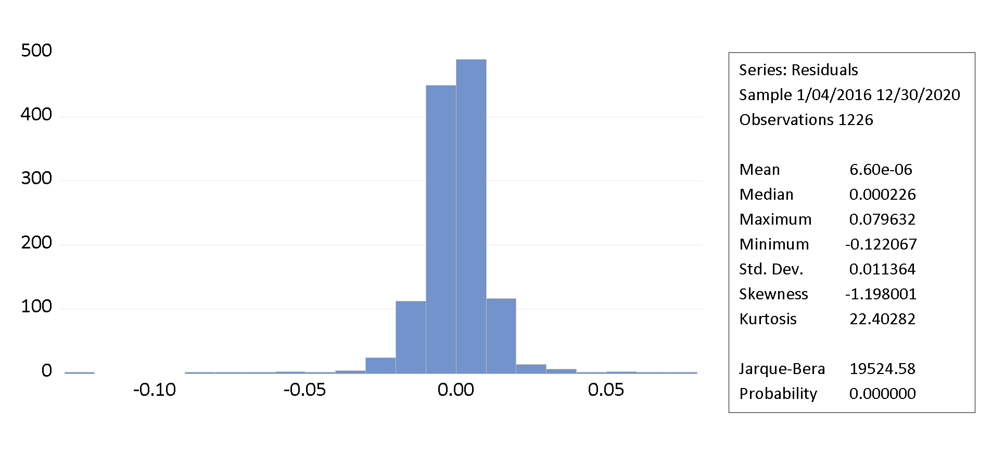

**Correlation**

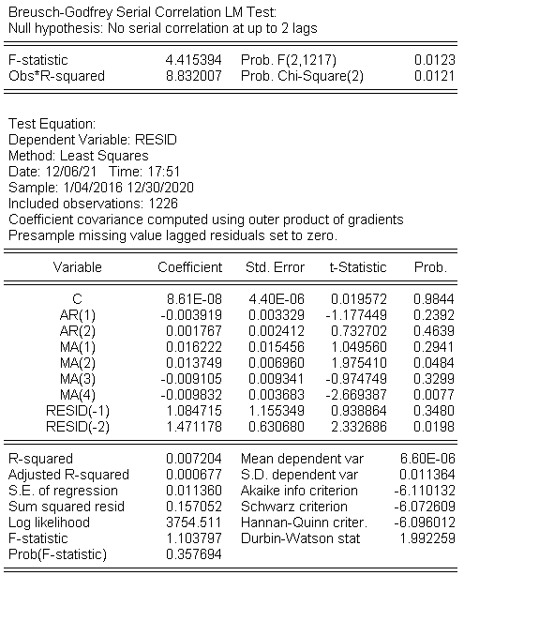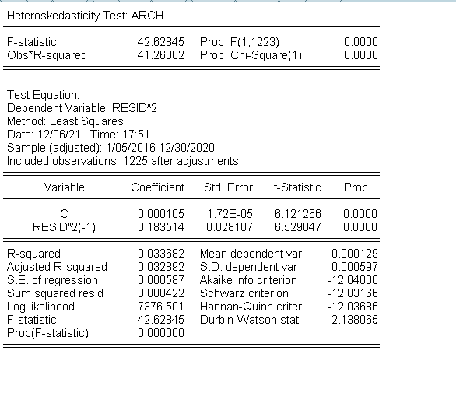

* In heteroskedasticity p < 5% heteroskedasticity is present
* In autocorrelation P < 10% hence autocorrelation exists
* AR(1), MA(1) , MA(4) are not significant
* Errors are not normal
* R squared is 2.06%

*We choose model (3,2) and (4,4) now we forecast them and compare the results*

**Forecasting for (2,3)**

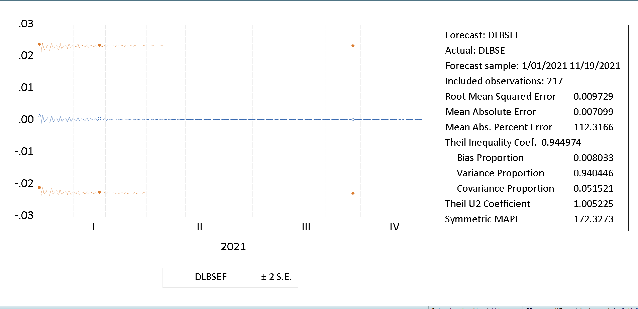

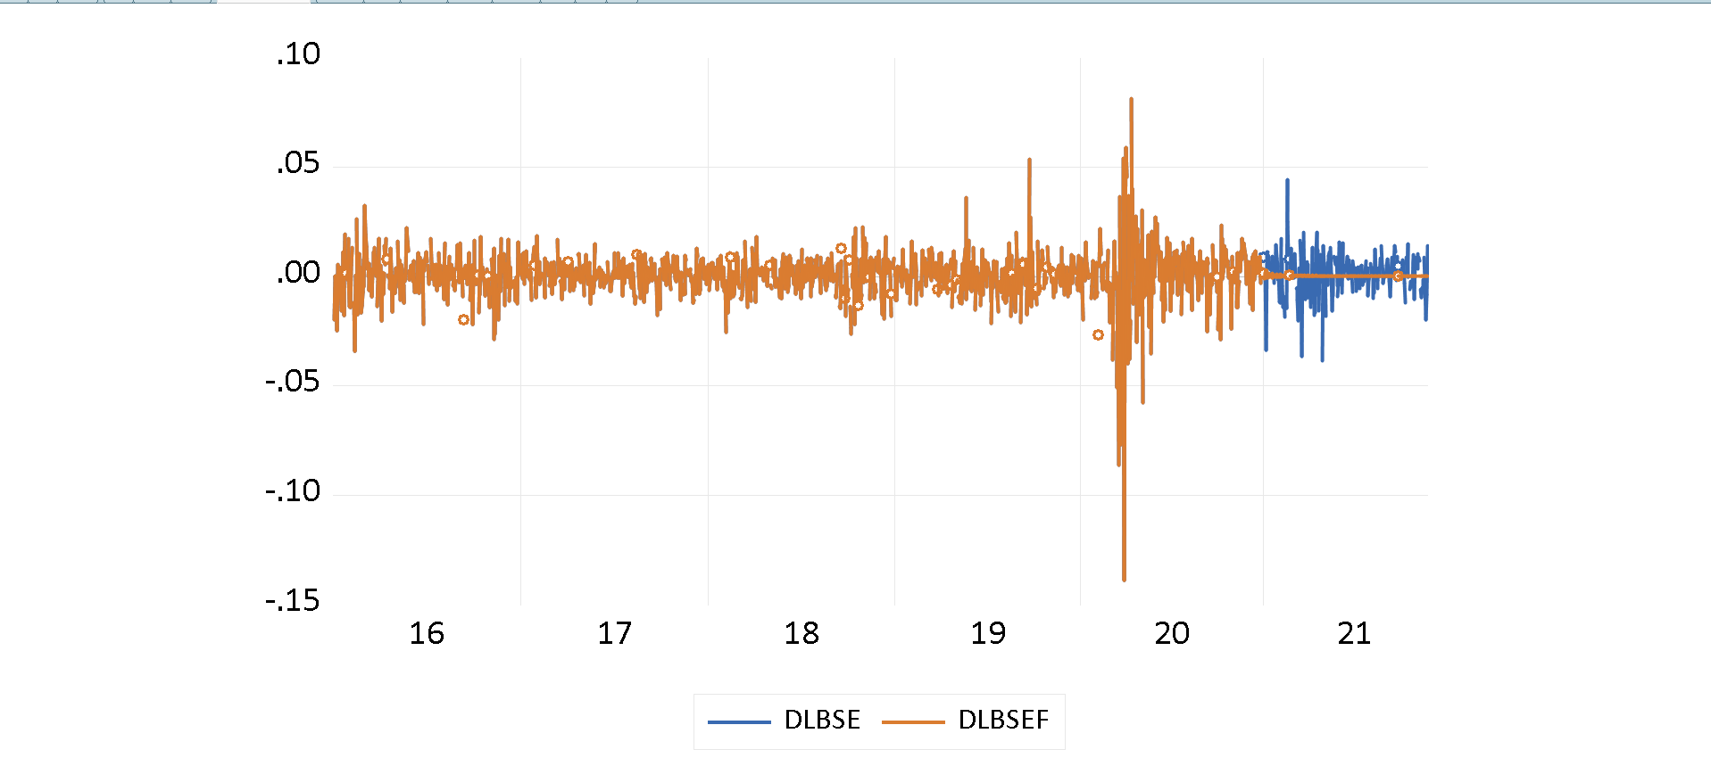

**Forecasting for (4,4)**

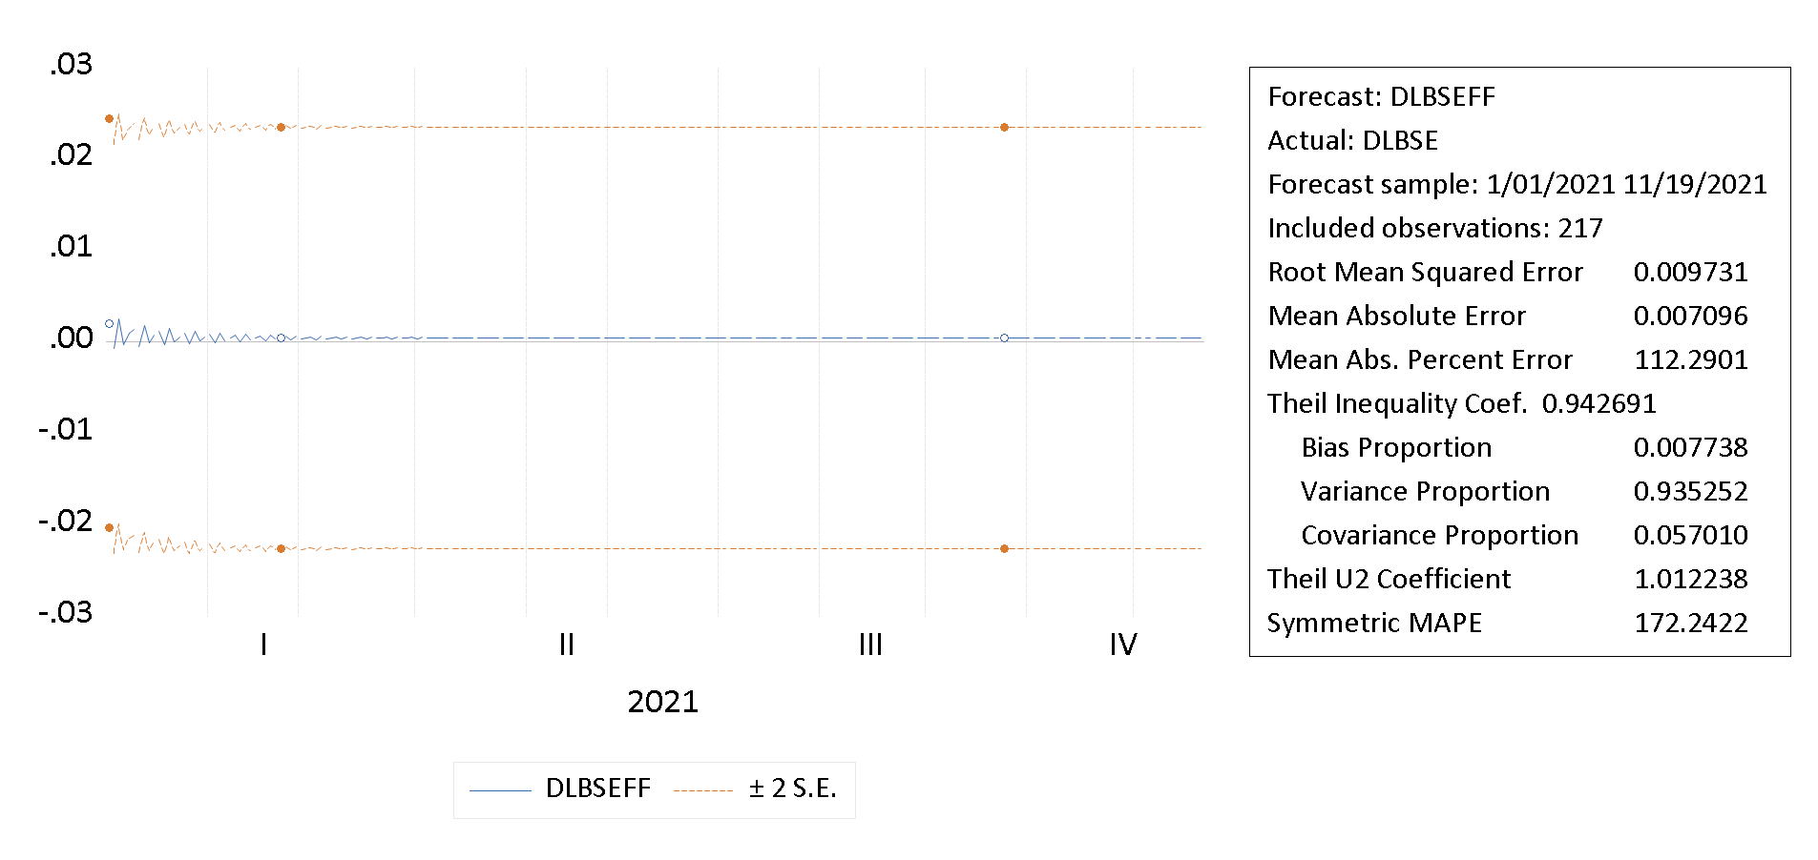

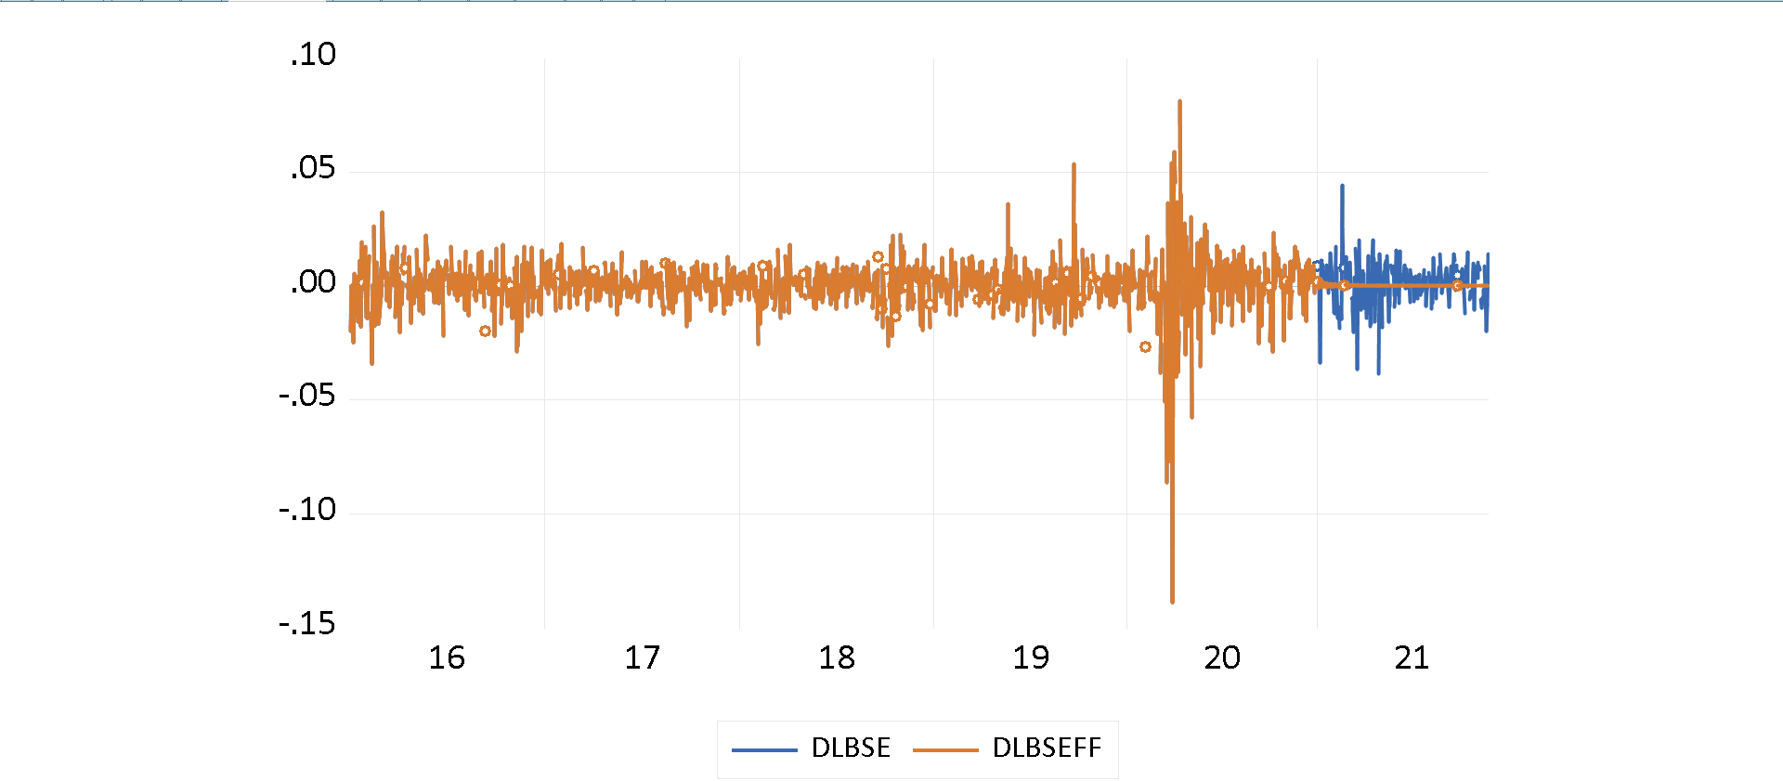

As the forecasting results are almost equal, i would choose model **(3,2)** over (4,4) because every AR and MA is significant in (3,2) while in (4,4) AR(2) and MA(2) are not significant